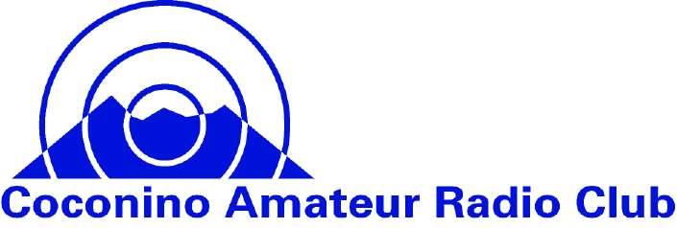

CARC Field Day 2020 Operating Criteria
Revision 6/11/2020

- Any amateur radio operator can participate in Field Day. All FCC rules always apply. Every CARC club member is encouraged to participate but no club membership is required. Each station selects the operating class they will use. See the 2020 ARRL Field Day Rules sections 4.2 – 4.8 and the 2020 Field Day Waivers.
- Each Station operates using their own call sign and the class they selected.
- If you do not have HF gear then “on the hour” make some contacts on 146.480 simplex. “On the ½ hour” use 446.500 simplex. You can log these contacts for points. There should be plenty of us CARC members there and also some new hams. Please take time to help out the new hams and your club.
- When submitting your entry, use Coconino ARC as your Club or Group Name. The ARRL will aggregate our club score.
- CARC members that make at least 10 contacts will also be counted in our annual contest with the Oro Valley Radio Club.
- Keep a log of your contacts. A blank log form is included on this web site,
- Participants will each submit their entry to ARRL and a copy to Phil, AE7OH, phil.brunner@gmail.com.
- Anyone that needs help of any kind please contact Ron, KG7OH at 480-356-3663, KG7OH@ARRL.org.

